TOWN OF DRAPER
ORDINANCE No. 3-87
The Town Board of the town of Draper, County of Sawyer,
Wisconsin does ordain as follows :
WHEREAS, the Town Board of the Town of Draper hereby agrees that Town Board meetings of the Town of Draper be maintained with decorum, specifically as relates to public participation, will henceforth request the departure from said town meetings of those persons (and/or person) who persist in disruptive behavior and/or
abusive speech, and who continually by verbal interruptions hinder
the conduction of said town board business.
Compliance shall be enforced by the Chair upon Supervisor request and Board approval.
This ordinance shall take effect and be in force from and after passage and publication,
In witness whereof the undersigned officers of the Town of
Draper have set their hands and seals this 31st day of July, 1987.

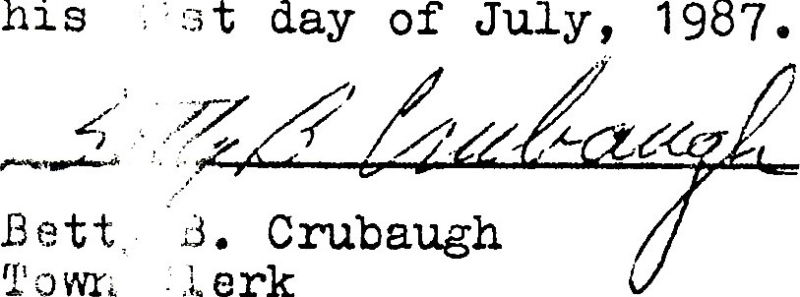
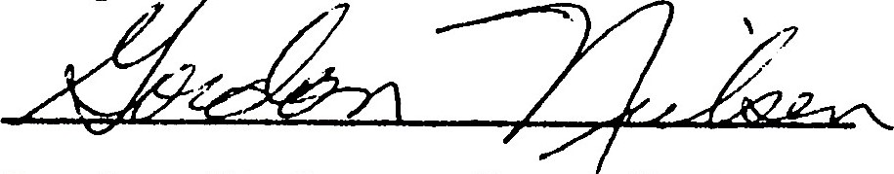

Gordon Nielsen, Town Chairman
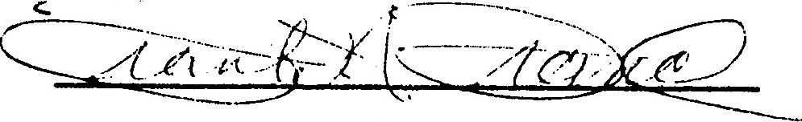

Frank Franc, First Supervisor
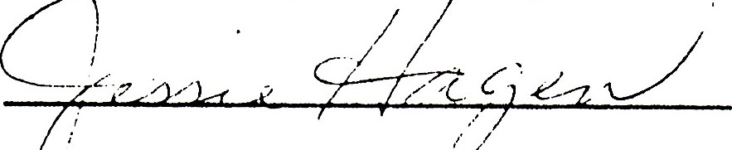
Jessie Hagen, Second Supervisor

